***This release and additional tables***

***of international statistics are***

***available on efama’s website***

***(***[***www.efama.org***](https://www.efama.org/statistics/SitePages/International%20Quarterly%20Statistical%20Release.aspx)***).***

## Worldwide Regulated Open-ended Fund Assets and Flows

**Trends in the Second Quarter of 2020**

Brussels, September 24, 2020 **–** Worldwide regulated open-ended fund assets increased by 9.8 percent to EUR 51.7 trillion in Q2 2020.[1] Worldwide net cash flow to all funds amounted to EUR 818 billion, compared to EUR 617 billion in Q1 2020.

The information presented in this report was compiled by EFAMA and the Investment Company Institute (ICI) on behalf of the International Investment Funds Association (IIFA), an organization of national investment fund associations. Statistics from 46 countries are included in this report.

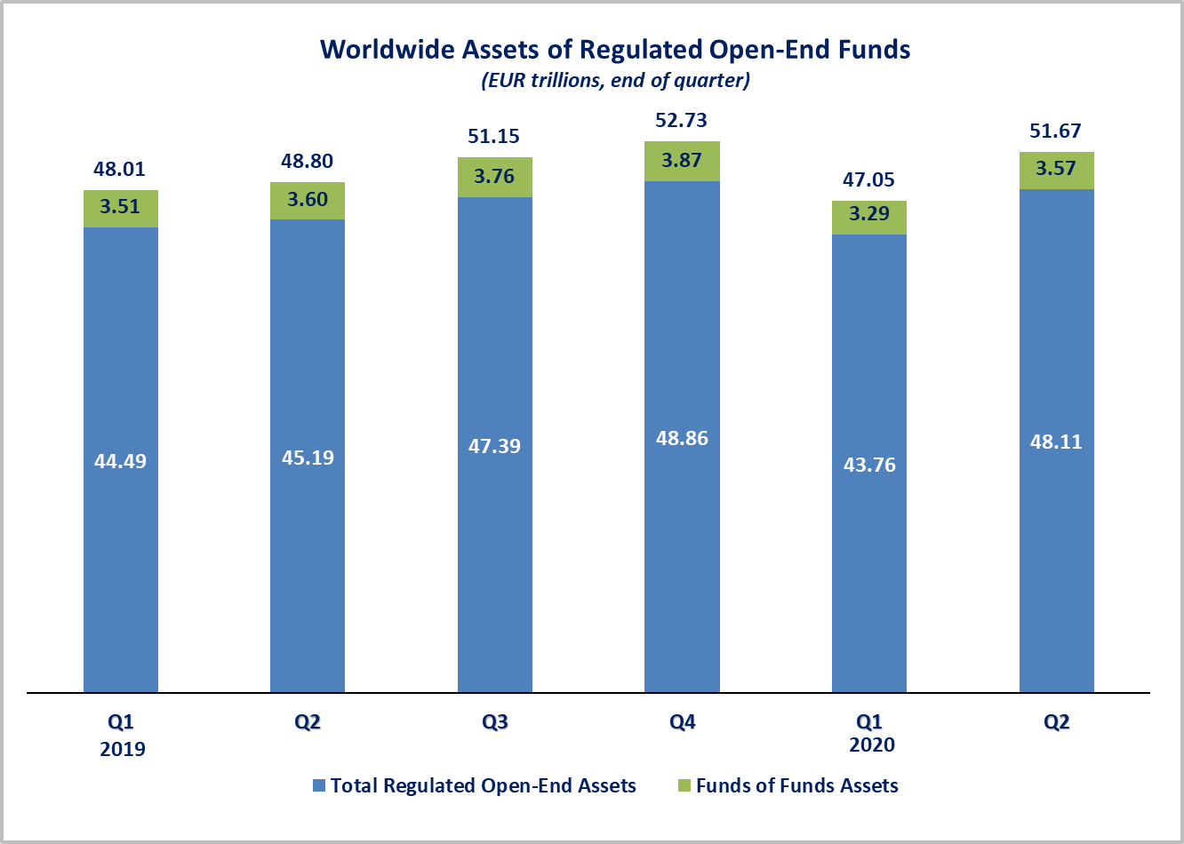

Measured in U.S. dollars, worldwide investment fund net assets increased to USD 57.9 trillion at the end of Q2 2020. This represented an increase of 12.3 percent. The following two graphs compare the net asset growth in the seven largest countries/regions.

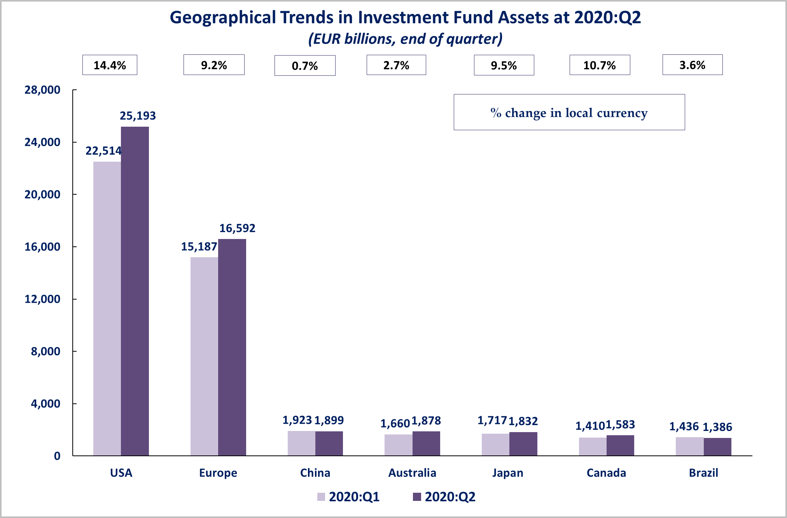



On a euro-denominated basis, worldwide equity fund assets increased by 16.5 percent to 20.7 trillion at the end of Q2 2020. Bond fund assets increased by 4.8 percent to EUR 10.7 trillion. Balanced/mixed fund assets increased by 8.7 percent to EUR 8.6 trillion. Money market funds increased by 3.8 percent to EUR 7.3 trillion.



At the end of Q2 2020, 40.1 percent of worldwide regulated open-ended fund net assets were held in equity funds. The asset share of bond funds was 20.8 percent and the asset share of balanced/mixed funds was 16.7 percent. Money market fund assets represented 14.1 percent of the worldwide total.

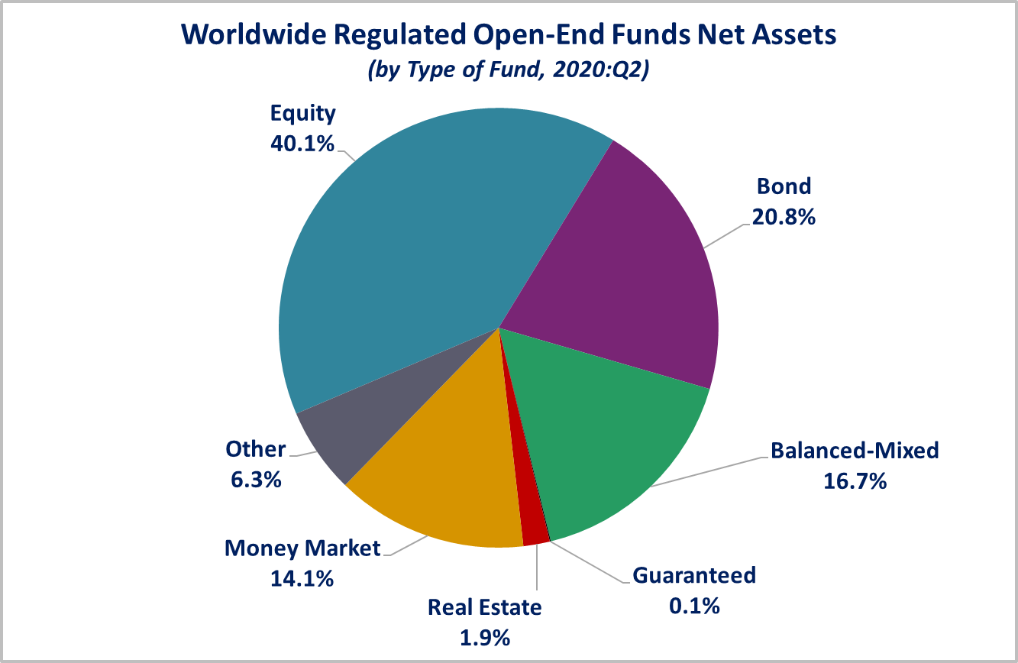

Looking at the worldwide distribution of investment fund net assets at end Q2 2020, the United States and Europe held the largest shares in the world market, with 48.8 percent and 32.1 percent, respectively. China (3.7%), Australia (3.6%), Japan (3.5%), Canada (3.1%), Brazil (2.7%), Rep. of Korea (1%), India (0.5%) and South Africa (0.3%) follow in this ranking.

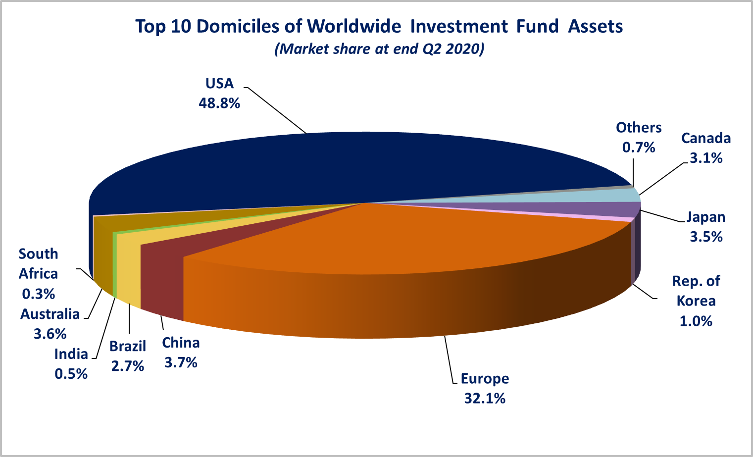

Overall, five European countries ranked among the top ten largest fund domiciles in the world: Luxembourg (with 8.9 percent of worldwide investment fund assets), Ireland (5.9%), Germany (4.5%), France (3.7%), and the United Kingdom (3%).

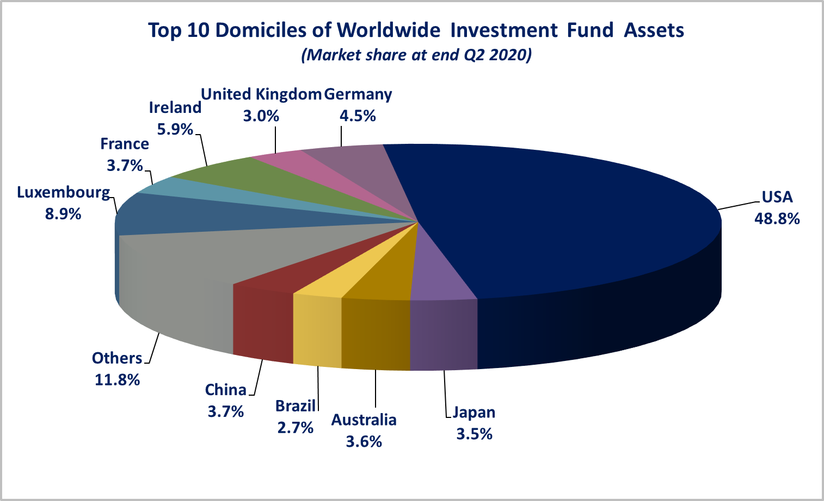

Worldwide net sales of regulated open-ended funds increased to EUR 818 billion in Q2 2020, from EUR 617 billion in Q1 2020. Long-term funds recorded net inflows of EUR 377 billion, compared to net outflows of EUR 213 billion in Q1 2020. Globally, equity funds recorded net inflows of EUR 4 billion, compared to net outflows of EUR 15 billion Q1 2020. Bond funds registered net inflows of EUR 279 billion, compared to net outflows of EUR 207 billion in Q1 2020. Balanced/mixed funds worldwide recorded net inflows of EUR 33 billion, compared to net outflows of EUR 39 billion in Q1 2020. Net sales of money market funds decreased from EUR 829 billion in Q1 2020 to EUR 441 billion in Q2 2020.

 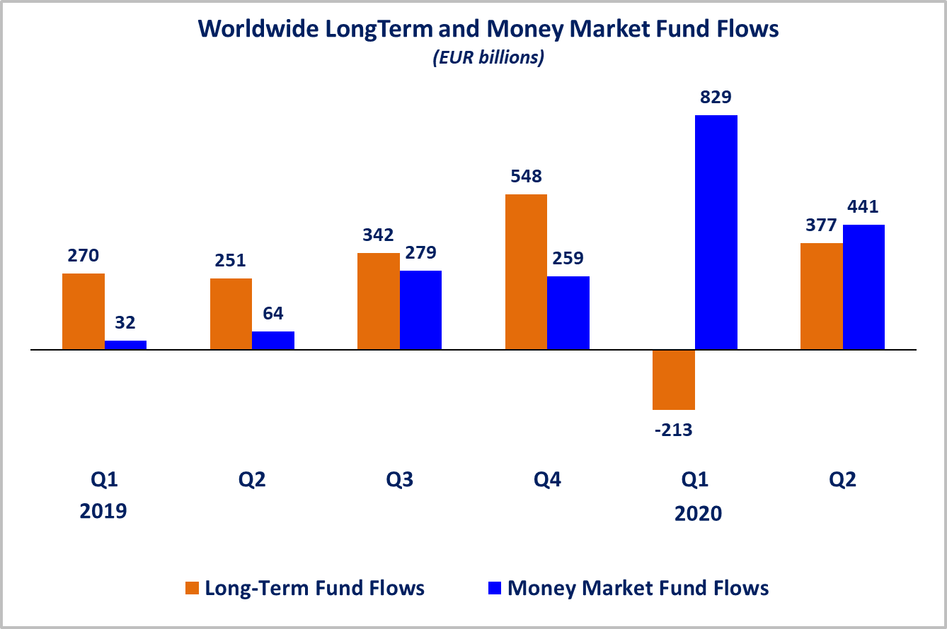Net sales of regulated open-ended funds reached EUR 415 billion in the United States and EUR 278 billion in Europe. Other advanced economies[2] recorded net inflows of EUR 74 billion (of which EUR 40 billion in Japan, EUR 16 billion in Canada and EUR 11 billion in Rep. of Korea). Emerging markets[3] recorded net inflows of EUR 52 billion, mainly driven by inflows in China (EUR 24 billion) and India (EUR 17 billion). Europe and other advanced economies experienced an increase in net sales compared to Q1 2020, mainly due to strong net inflows into bond funds and money market funds.

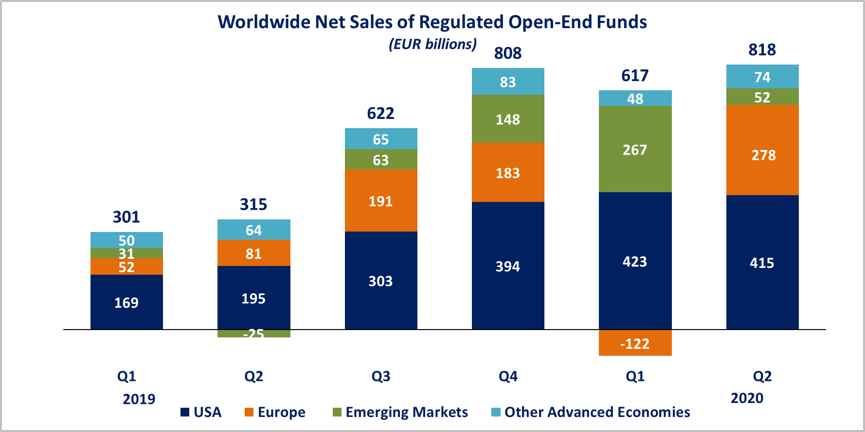

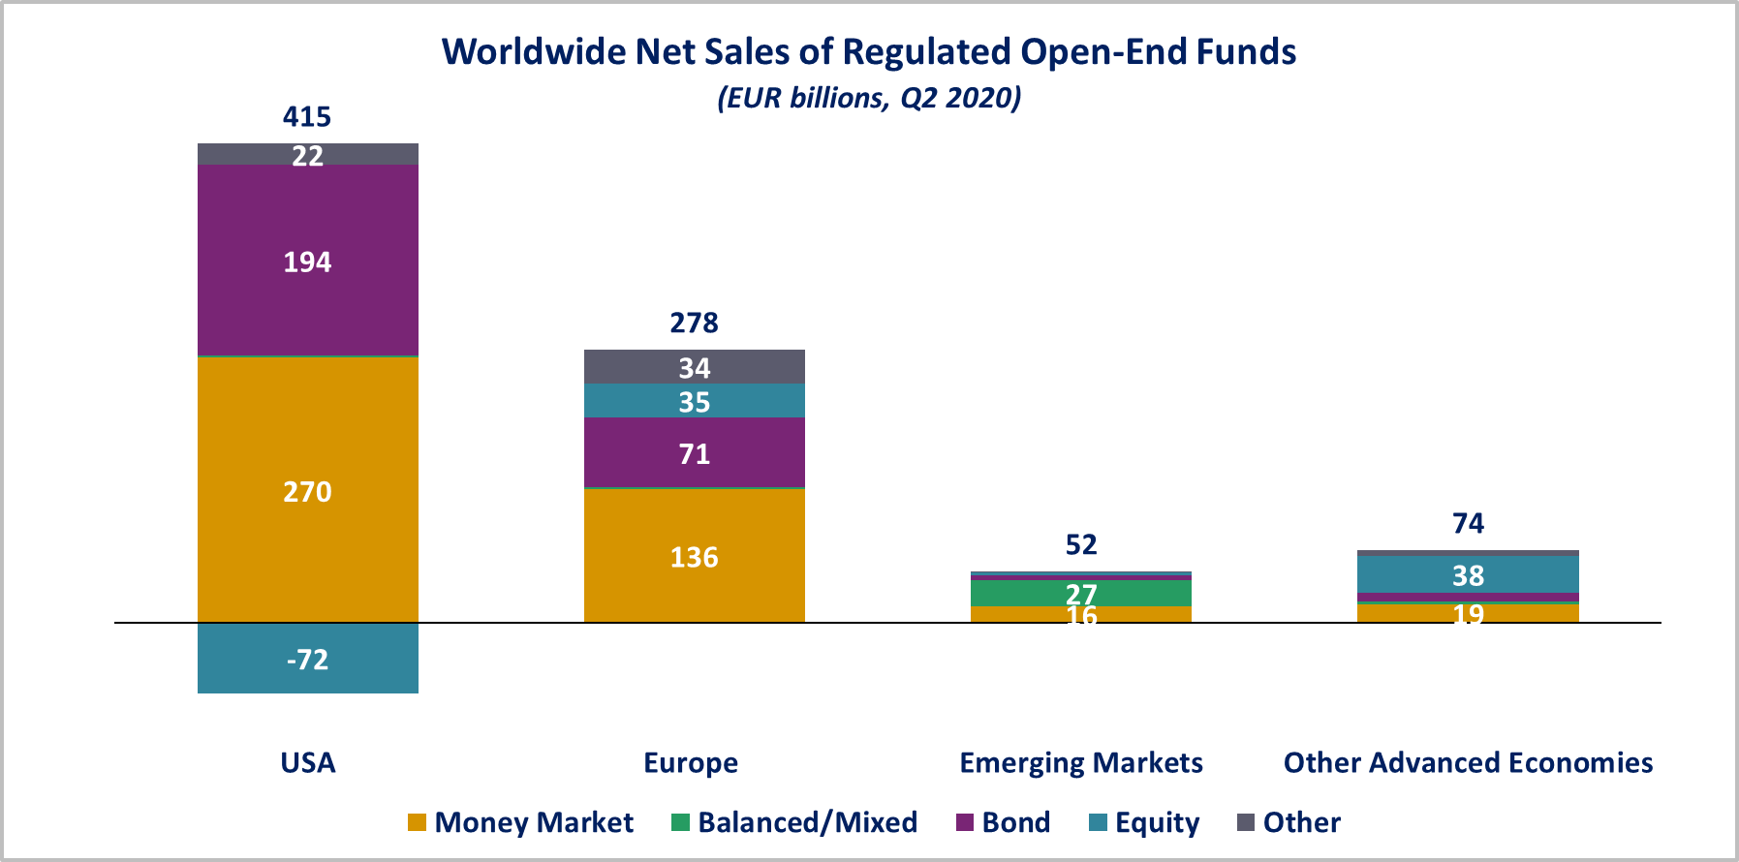

In Europe, long-term funds recorded net inflows of EUR 141 billion, compared to net outflows of EUR 122 billion in Q1 2020. Equity funds recorded net inflows of EUR 35 billion, compared to net outflows of EUR 51 billion in Q1 2020. Bond funds recorded net inflows of EUR 71 billion, compared to net outflows of EUR 81 billion in Q1 2020. Balanced/mixed funds registered net inflows of EUR 2 billion, compared to net outflows of EUR 11 billion in Q1 2020. Money market funds recorded net inflows of EUR 136 billion, compared to net outflows of EUR 0.1 billion in Q1 2020.

In the United States, long-term open-ended funds recorded net inflows of EUR 146 billion, compared to net outflows of EUR 215 billion in Q1 2020. Equity funds recorded net outflows of EUR 72 billion, compared to net outflows of EUR 29 billion in Q1 2020. Bond funds recorded net inflows of EUR 194 billion, compared to net outflows of EUR 135 billion in Q1 2020. Balanced/mixed funds registered net inflows of EUR 2 billion, compared to net outflows of EUR 61 billion in Q1 2020. Net sales of money market funds decreased from EUR 638 billion in Q1 2020 to EUR 270 billion in Q2 2020.

**Regional Summary Table by Type of Fund, Q2 2020**



1. All data presented in this report include funds of funds, exchange-traded funds and institutional funds.
2. Other advanced economies are countries thus defined by the International Monetary Fund, based on criteria such as per capita income level and the degree of integration into the global financial system, excluding the US and the countries included in the Europe aggregate. Data is not available for all advanced economies. Other advanced economies include Australia, Canada, Japan, Korea, New Zealand and Chinese Taipei (Taiwan).
3. Emerging markets are countries thus defined by the International Monetary Fund. Data is not available for all emerging markets. The following countries are included: Argentina, Brazil, Chile, China, Costa Rica, India, Mexico, Pakistan, the Philippines and South Africa.